
MOFFAT BAY LODGE

Accommodations
About Us
Activities
Dining & More
Home

Bayside Dining with a View
Enjoy fresh, locally inspired meals at Moffat Bay Lodge while taking in stunning waterfront views.
Whether you’re sitting down for a full meal or grabbing something quick before heading out, our
dining options are designed for both comfort and convenience.

After your meal, relax and enjoy the peaceful surroundings of Moffat Bay, or continue your day
exploring everything the lodge has to offer.
Dining at Moffat Bay

Grab & Go Options – Moffat Bay Canteen
For guests on the move, the canteen is open 24/7 and offers quick and convenient options.
- Sandwiches and wraps
- Salads, fruit, and light snacks
- Pastries, muffins, and baked goods
- Hot and cold beverages
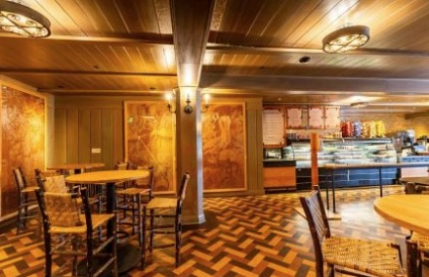
Prefect for:
- Early morning excursions
- Outdoor adventures
- Guest who prefers quick, convenient meals

Lodge Dining Experience
Our lodge dining area offers:
- Freshly prepared lunch, and dinner options
- Locally sourced Pacific Northwest ingredients
- Comfortable indoor seating with scenic lake views
- A warm, rustic atmosphere perfect for relaxing after a day outdoors
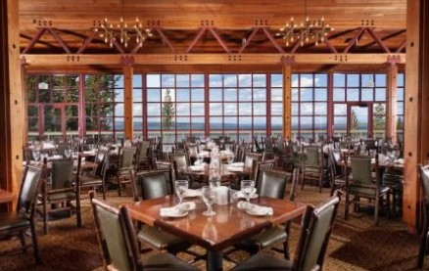
Operating Dates
- Opens: April 2026
- Closes: October 2026
Reservations
- No reservation required
- First come, first served

Dress Code
- Casual

